Name: __________________________ Hour: _____________________

Electromagnetic Radiation Exercise

Define electromagnetic radiation:

Define electromagnetic spectrum:

Observation (White Light Separated!)

After observing your teacher “catch a rainbow”, color this image to show the separation of white light into the visible spectrum. Your image should have the colors of ROYGBIV in the right order and the colors should be labeled. You’ll have one extra block – you may leave that uncolored or fade red and violet into it.

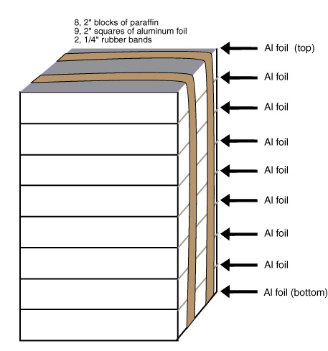

Hypothesize

Make your best guess to explain what you just saw. (ex: Why were the colors separated in the block of wax?) You may get up to look at the wax block or to try catching a rainbow yourself.

Light – More than Meets the Eye (or Beyond Visible!)

The Electromagnetic Spectrum
Fill in the types of electromagnetic radiation (ex: M is for Microwave). Underneath each type, write in two examples of this where we would find this type of radiation (one example for microwave is from a microwave oven).

Wavelengths in Meters
10² 10⁻² 10⁻⁵ 10⁻⁷ 10⁻⁸ 10⁻¹⁰ 10⁻¹³
R M I V U X G
microwave
oven

Mnemonic Device

Come up with your own Mnemonic Device that would help you remember which order the forms of electromagnetic radiation go in from biggest wavelength to shortest wavelength (R-M-I-V-U-X-G). (Ex: Really MrsB Is Very, Ultimately, Xtra Great)

Conversion Factors for wavelength

Convert each of the given wavelengths from meters to nanometers and then to Angstroms. Use these conversion factors: 1 nm = 10⁻⁹ meters and 1 nanometer = 10 Aº
Show your work on the back of this sheet!!

